CONCEPT CHECK

QUESTIONS AND ANSWERS

**Chapter 2**

Atomic Structure and Interatomic Bonding

Concept Check 2.1

Question: *Why are the atomic weights of the elements generally not integers? Cite two reasons.*

Answer: The atomic weights of the elements ordinarily are not integers because: (1) the atomic masses of the atoms normally are not integers (except for 12C), and (2) the atomic weight is taken as the weighted average of the atomic masses of an atom's naturally occurring isotopes.

Concept Check 2.2

Question:  *Give electron configurations for the Fe3+and S2- ions.*

Answer: The Fe3+ ion is an iron atom that has lost three electrons. Since the electron configuration of the Fe atom is 1*s*22*s*22*p*63*s*23*p*63*d*64*s*2 (Table 2.2), the configuration for Fe3+ is 1*s*22*s*22*p*63*s*23*p*63*d*5.

The S2- ion a sulfur atom that has gained two electrons. Since the electron configuration of the S atom is 1*s*22*s*22*p*63*s*23*p*4 (Table 2.2), the configuration for S2- is 1*s*22*s*22*p*63*s*23*p*6.

Concept Check 2.3

Question: *Explain why covalently bonded materials are generally less dense than ionically or metallically bonded ones.*

Answer: Covalently bonded materials are less dense than metallic or ionically bonded ones because covalent bonds are directional in nature whereas metallic and ionic are not; when bonds are directional, the atoms cannot pack together in as dense a manner, yielding a lower mass density.

**Chapter 3**

Structures of Metals and Ceramics

Concept Check 3.1

Question: *Table 3.4 gives the ionic radii for K+ and O2- as 0.138 and 0.140 nm, respectively.*

*(a) What is the coordination number for each O2- ion?*

*(b) Briefly describe the resulting crystal structure for K2O.*

*(c) Explain why this is called the antifluorite structure.*

Answer: (a) First, let us find the coordination number of each O2- ion for K2O. Taking the cation-anion radii ratio



From Table 3.3, the coordination number for oxygen is eight.

(b) According to Table 3.5, for a coordination number of eight for both cations and anions, the crystal structure should be cesium chloride. However, there are twice as many K+ as O2- ions. Therefore, the centers of the K+ ions are positioned at the corners of cubic unit cells, while half of the cube centers are occupied by O2- ions.

(c) This structure is called the antifluorite crystal structure because anions and cations are interchanged with one another from the fluorite structure (Figure 3.8).

Concept Check 3.2

Question: *What is the difference between crystal structure and crystal system?*

Answer: A crystal structure is described by both the geometry of, and atomic arrangements within, the unit cell, whereas a crystal system is described only in terms of the unit cell geometry. For example, face-centered cubic and body-centered cubic are crystal structures that belong to the cubic crystal system.

Concept Check 3.3

Question: *For cubic crystals, as values of the planar indices h, k, and* *l increase, does the distance between adjacent and parallel planes (i.e., the interplanar spacing) increase or decrease? Why?*

Answer: The interplanar spacing between adjacent and parallel planes *decreases* as the values of *h*, *k*, and *l* increase. As values of the planar indices increase, the magnitude of the denominator in Equation 3.17 increases, with the result that the interplanar spacing (*dhkl*) decreases.

Concept Check 3.4

Question: *Do noncrystalline materials display the phenomenon of allotropy (or polymorphism)? Why or why not?*

Answer: Noncrystalline materials *do not* display the phenomenon of allotropy; since a noncrystalline material does not have a defined crystal structure, it cannot have more than one crystal structure, which is the definition of allotropy.

Concept Check 3.5

Question: *Do noncrystalline materials have grain boundaries? Why or why not?*

Answer: Noncrystalline materials *do not* have grain boundaries; since noncrystalline materials do not have grains (which are crystalline) they don't have grain boundaries.

**Chapter 4**

Polymer Structures

Concept Check 4.1

Question: *Differentiate between polymorphism (see Chapter 3) and isomerism.*

Answer: *Polymorphism* is when two or more crystal structures are possible for a material of given composition. *Isomerism* is when two or more polymer molecules or repeat units have the same composition, but different atomic arrangements.

Concept Check 4.2

Question: *On the basis of the structures presented in the previous section, sketch the repeat unit structure for poly(vinyl fluoride).*

Answer: Inasmuch as poly(vinyl *chloride*) has the repeat unit structure shown in Figure 4.2(b), replacing the side-bonded chlorine atom with a fluorine atom will yield a poly(vinyl *fluoride*) repeat unit, as shown below.

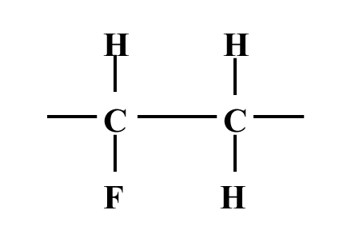

Concept Check 4.3

Question: *What is the difference between configuration and conformation in relation to polymer chains?*

Answer: Relative to polymer chains, the difference between *configuration* and *conformation* is that conformation is used in reference to the outline or shape of the chain molecule, whereas, configuration refers to the arrangement of atom positions along the chain that are not alterable except by the breaking and reforming of primary bonds.

Concept Check 4.4

Question: *Some polymers (such as the polyesters) may be either thermoplastic or thermosetting. Suggest one reason for this.*

Answer: Thermosetting polyesters will be crosslinked, while thermoplastic ones will have linear structures without any appreciable crosslinking.

Concept Check 4.5

Question: *(a)* *Compare the crystalline state in metals and polymers.* *(b)* *Compare the noncrystalline state as it applies to polymers and ceramic glasses.*

Answers: (a) For crystalline metals, the individual atoms are positioned in a periodic or ordered arrangement over relatively large atomic distances. The long-range order in polymer crystals results from the packing of adjacent polymer chains.

(b) For noncrystalline ceramic glasses, the atomic randomness exists outside the  unit. The disorder in polymers results from chain misalignment.

**Chapter 5**

Imperfections in Solids

Concept Check 5.1

Question: *Can Schottky defects exist in K2O? If so, briefly describe this type of defect. If they cannot exist, then explain why.*

Answer: This question can be answered in two ways, as follows:

(1) Yes, Schottky defects can exist in K2O; each defect will consist of one O2- vacancy and two K+ vacancies.

(2) No, in the strict sense, Schottky cannot exist in K2O if we consider this type of defect to consist of a cation-anion pair; for every O2- vacancy created there must exist two K+ vacancies.

Concept Check 5.2

Question: *What point defects are possible for MgO as an impurity in Al2O3? How many Mg2+ ions must be added to form each of these defects?*

Answer: For every Mg2+ ion that substitutes for Al3+ in Al2O3, a single positive charge is removed. Thus, in order to maintain charge neutrality, either a positive charge must be added or a negative charge must be removed.

Positive charges are added by forming Al3+ interstitials, and one Al3+ interstitial would be formed for every three Mg2+ ions added.

Negative charges may be removed by forming O2- vacancies, and one oxygen vacancy would be formed for every two Mg2+ ions added.

Concept Check 5.3

Question: *The surface energy of a single crystal depends on crystallographic orientation. Does this surface energy increase or decrease with an increase in planar density? Why?*

Answer: The surface energy of a single crystal depends on the planar density (i.e., degree of atomic packing) of the exposed surface plane because of the number of unsatisfied bonds. As the planar density increases, the number of nearest atoms in the plane increases, which results in an increase in the number of satisfied atomic bonds in the plane, and a decrease in the number of unsatisfied bonds. Since the number of unsatisfied bonds diminishes, so also does the surface energy decrease. (That is, surface energy decreases with an increase in planar density.)

Concept Check 5.4

Question: *Does the grain size number (n of Equation 5.19) increase or decrease with decreasing grain size? Why?*

Answer: Taking logarithms of Equation 5.19 and then rearranging such that the grain size number *n* is the dependent variable leads to the expression



Thus, *n* increases with increasing *N*. But as *N* (the average number of grains per square inch at a magnification of 100 times) increases the grain size decreases. In other words, the value of *n* *increases* with decreasing grain size.

**Chapter 6**

Diffusion

Concept Check 6.1

Question: *Rank the magnitudes of the diffusion coefficients from greatest to least for the following systems:*

*N in Fe at 700C*

*Cr in Fe at 700C*

*N in Fe at 900C*

*Cr in Fe at 900C*

*Now justify this ranking.* (*Note: Both Fe and Cr have the BCC crystal structure, and the atomic radii for Fe, Cr, and N are 0.124, 0.125, and 0.065 nm, respectively. You may also want to refer to Section 5.4*.)

Answer: The diffusion coefficient magnitude ranking is as follows:

N in Fe at 900C; *D*N(900)

N in Fe at 700C; *D*N(700)

Cr in Fe at 900C; *D*Cr(900)

Cr in Fe at 700C; *D*Cr(700)

Nitrogen is an interstitial impurity in Fe (on the basis of its atomic radius), whereas Cr is a substitutional impurity. Since interstitial diffusion occurs more rapidly than substitutional impurity diffusion, *D*N > *D*Cr. Also, inasmuch as the magnitude of the diffusion coefficient increases with increasing temperature, *D*(900) > *D*(700).

Concept Check 6.2

Question: *Consider the self-diffusion of two hypothetical metals A and B. On a schematic graph of ln D versus 1/T, plot (and label) lines for both metals given that D*0(A) *> D*0(B) *and also that Qd*(A) *> Qd*(B).

Answer: The schematic ln *D* versus 1/*T* plot with lines for metals A and B is shown below.

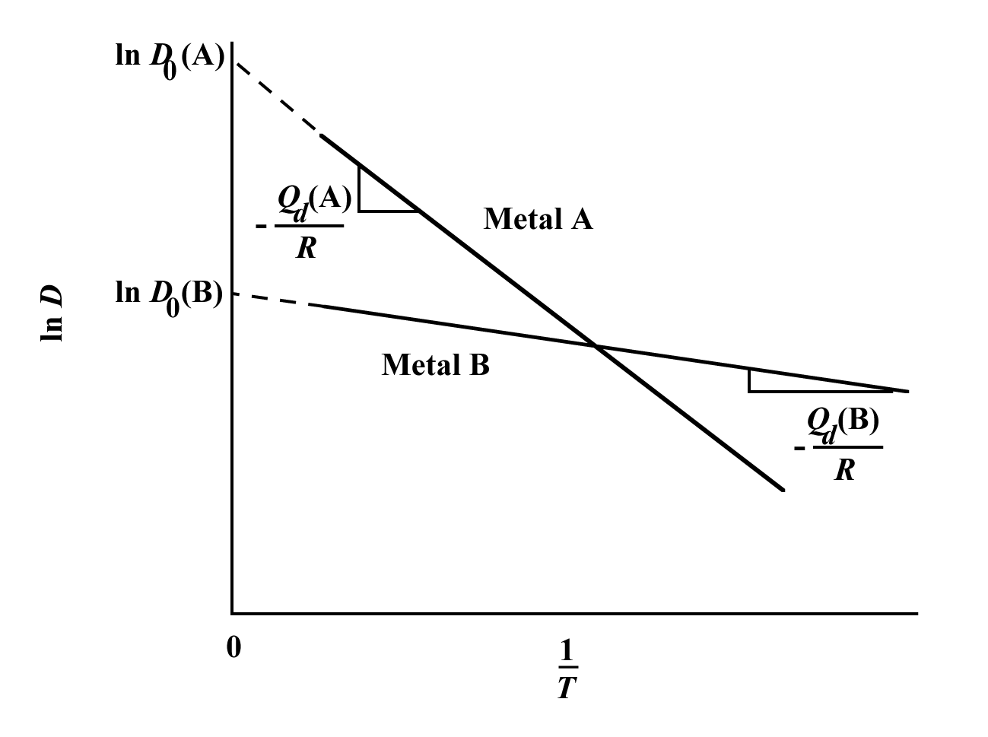

As explained in the previous section, the intercept with the vertical axis is equal to ln *D*0. As shown in this plot, the intercept for metal A is greater than for metal B inasmuch as *D*0(A) > *D*0(B) [alternatively ln *D*0(A) > ln *D*0(B)]. In addition, the slope of the line is equal to –*Qd/R*. The two lines in the plot have been constructed such that negative slope for metal A is greater than for metal B, inasmuch as *Qd*(A) > *Qd*(B)

**Chapter 7**

Mechanical Properties

Concept Check 7.1

Questions: *Of those metals listed in Table 7.3:*

*(a) Which will experience the greatest percent reduction in area? Why?*

*(b) Which is the strongest? Why?*

*(c) Which is the stiffest? Why?*

Table 7.3 Tensile stress-strain data for several hypothetical metals to be used with Concept Checks 7.1 and 7.6

Yield Tensile Strain Fracture Elastic

Strength Strength at Strength Modulus

Material (MPa) (MPa) Fracture (MPa) (GPa)

A 310 340 0.23 265 210

B 100 120 0.40 105 150

C 415 550 0.15 500 310

D 700 850 0.14 720 210

E Fractures before yielding 650 350

Answers:

(a) Material B will experience the greatest percent area reduction since it has the highest strain at fracture, and, therefore is most ductile.

(b) Material D is the strongest because it has the highest yield and tensile strengths.

(c) Material E is the stiffest because it has the highest elastic modulus.

Concept Check 7.2

Question: *Make a schematic plot showing the tensile engineering stress–strain behavior for a typical metal alloy to the point of fracture. Now superimpose on this plot a schematic compressive engineering stress-strain curve for the same alloy. Explain any differences between the two curves.*

Answer: The schematic stress-strain graph on which is plotted the two curves is shown below.

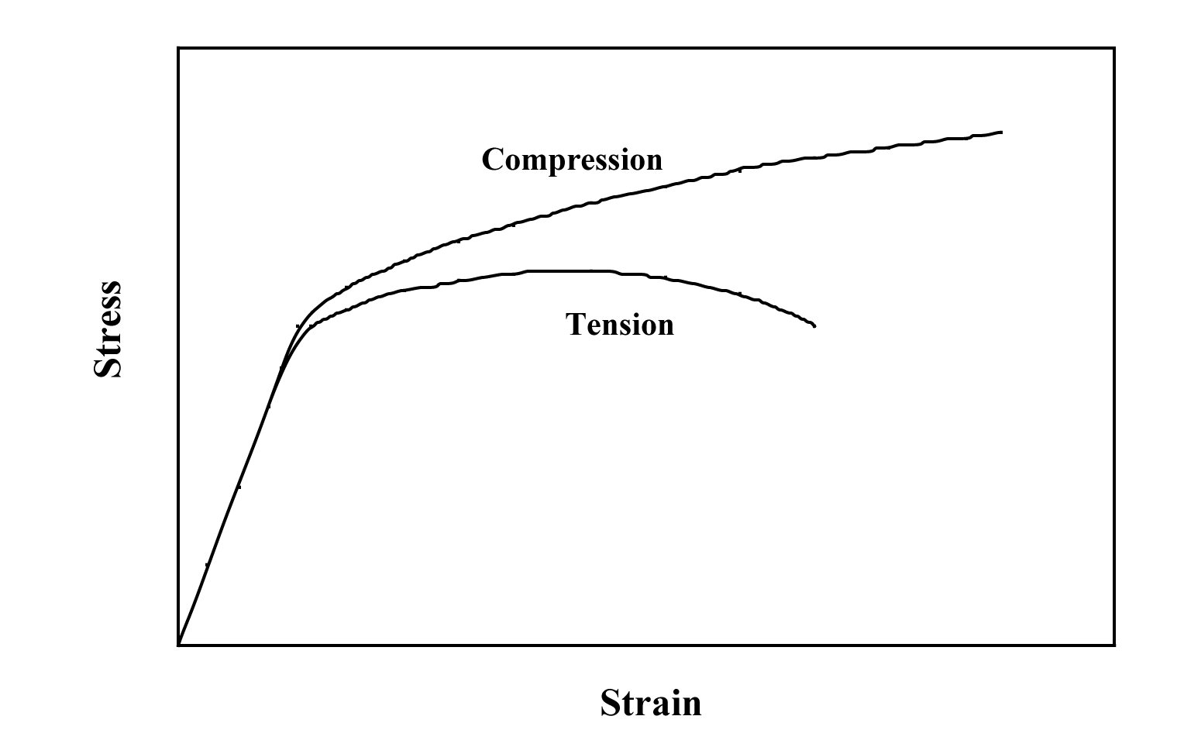

The initial linear (elastic) portions of both curves will be the same. Otherwise, there are three differences between the two curves, which are as follows:

(1) Beyond the elastic region, the tension curve lies below the compression one. The reason for this is that, during compression, the cross-sectional area of the specimen is increasing—that is, for two specimens that have the same initial cross-sectional area (*A*0), at some specific strain value the instantaneous cross-sectional area in compression will be greater than in tension. Consequently, the applied force necessary to continue deformation will be greater for compression than for tension; and, since stress is defined according to Equation 7.1 as



the applied force is greater for compression, so also will the stress be greater (since *A*0 is the same for both cases).

(2) The compression curve will not display a maximum inasmuch as the specimen tested in compression will not experience necking—the cross-sectional area over which deformation is occurring is continually increasing for compression.

(3) The strain at which failure occurs will be greater for compression. Again, this behavior is explained by the lack of necking for the specimen tested in compression.

Concept Check 7.3

Question: *When citing the ductility as percent elongation for semicrystalline polymers, it is not necessary to specify the specimen gauge length, as is the case with metals. Why is this so?*

Answer: The reason that it is not necessary to specify specimen gauge length when citing percent elongation for semicrystalline polymers is because, for semicrystalline polymers that experience necking, the neck normally propagates along the entire gauge length prior to fracture; thus, there is no localized necking as with metals and the magnitude of the percent elongation is independent of gauge length.

Concept Check 7.4

Question: *Cite the primary differences among elastic, anelastic, viscoelastic, and plastic deformation behaviors.*

Answer: Elastic deformation is time-independent and nonpermanent, anelastic deformation is time-dependent and nonpermanent, viscoelastic deformation is both instantaneous and time-dependent and is not totally recoverable, while plastic deformation is permanent.

Concept Check 7.5

Question: *An amorphous polystyrene that is deformed at 120C will exhibit which of the behaviors shown in Figure 7.26?*

Answer: Amorphous polystyrene at 120C behaves as a rubbery material (Figure 7.29, curve *C*); therefore, the strain-time behavior would be as Figure 7.26(c).

Concept Check 7.6

Question: *Of those metals listed in Table 7.3, which is the hardest? Why?*

Answer: Material D is the hardest because it has the highest tensile strength.

**Chapter 8**

Deformation and Strengthening Mechanisms

Concept Check 8.1

Question: *Which of the following is the slip system for the simple cubic crystal structure? Why?*









(*Note:* *a unit cell for the simple cubic crystal structure is shown in Figure 3.43.*)

Answer: The slip system for some crystal structure corresponds to the most densely packed crystallographic plane, and, in that plane, the most closely packed crystallographic direction. For simple cubic, the most densely packed atomic plane is the {100} type plane; the most densely packed direction within this plane is an  type direction. Therefore, the slip system for simple cubic is .

Concept Check 8.2

Question: *Explain the difference between resolved shear stress and critical resolved shear stress*.

Answer: *Resolved shear stress* is the shear component of an applied tensile (or compressive) stress resolved along a slip plane that is other than perpendicular or parallel to the stress axis. The *critical resolved shear stress* is the value of resolved shear stress at which yielding begins; it is a property of the material.

Concept Check 8.3

Question: *When making hardness measurements, what will be the effect of making an indentation very close to a preexisting indentation? Why?*

Answer: The hardness measured from an indentation that is positioned very close to a preexisting indentation will be high. The material in this vicinity was cold-worked when the first indentation was made.

Concept Check 8.4

Question: *Would you expect a crystalline ceramic material to strain harden at room temperature? Why or why not?*

Answer: No, it would not be expected. In order for a material to strain harden it must be plastically deformed; since ceramic materials are brittle at room temperature, they will fracture before any plastic deformation takes place.

Concept Check 8.5

Question: *Briefly explain why some metals (e.g., lead and tin) do not strain harden when deformed at room temperature.*

Answer: Metals such as lead and tin do not strain harden at room temperature because their recrystallization temperatures lie below room temperature (Table 8.2).

Concept Check 8.6

Question: *Would you expect it to be possible for ceramic materials to experience recrystallization? Why or why not?*

Answer: No, recrystallization is not expected in ceramic materials. In order to experience recrystallization, a material must first be plastically deformed, and ceramic materials are too brittle to be plastically deformed.

Concept Check 8.7

Question: *For the following pair of polymers, do the following: (1) state whether it is possible to decide if one polymer has a higher tensile modulus than the other; (2) if this is possible, note which has the higher tensile modulus and then cite the reason(s) for your choice; and (3) if it is not possible to decide, then state why not.*

*Syndiotactic polystyrene having a number-average molecular weight of 400,000 g/mol*

*Isotactic polystyrene having a number-average molecular weight of 650,000 g/mol*

Answer: No, it is *not possible*. Both syndiotactic and isotactic polystyrene have a tendency to crystallize, and, therefore, we assume that they have approximately the same crystallinity. Furthermore, since tensile modulus is virtually independent of molecular weight, we would expect both materials to have approximately the same modulus.

Concept Check 8.8

Question: *For the following pair of polymers, do the following: (1) state whether it is possible to decide if one polymer has a higher tensile strength than the other; (2) if this is possible, note which has the higher tensile strength and then cite the reason(s) for your choice; and (3) if it is not possible to decide, then state why not.*

*Syndiotactic polystyrene having a number-average molecular weight of 600,000 g/mol*

*Isotactic polystyrene having a number-average molecular weight of 500,000 g/mol*

Answer: Yes, it *is possible*. The syndiotactic polystyrene has the higher tensile strength. Both syndiotactic and isotactic polymers tend to crystallize, and, therefore, we assume that both materials have approximately the same crystallinity. However, tensile modulus increases with increasing molecular weight, and the syndiotactic PS has the higher molecular weight (600,000 g/mol versus 500,000 g/mol for the isotactic material).

Concept Check 8.9

Question: *For the following pair of polymers, plot and label schematic stress-strain curves on the same graph.*

*Poly(styrene-butadiene) random copolymer having a number-average molecular weight of 100,000 g/mol and 10% of the available sites crosslinked and tested at 20C*

*Poly(styrene-butadiene) random copolymer having a number-average molecular weight of 120,000 g/mol and 15% of the available sites crosslinked and tested at –85C*

*Hint: poly(styrene-butadiene) copolymers may exhibit elastomeric behavior.*

Answer: Shown below are the stress-strain curves for the two poly(styrene-butadiene) random copolymers.

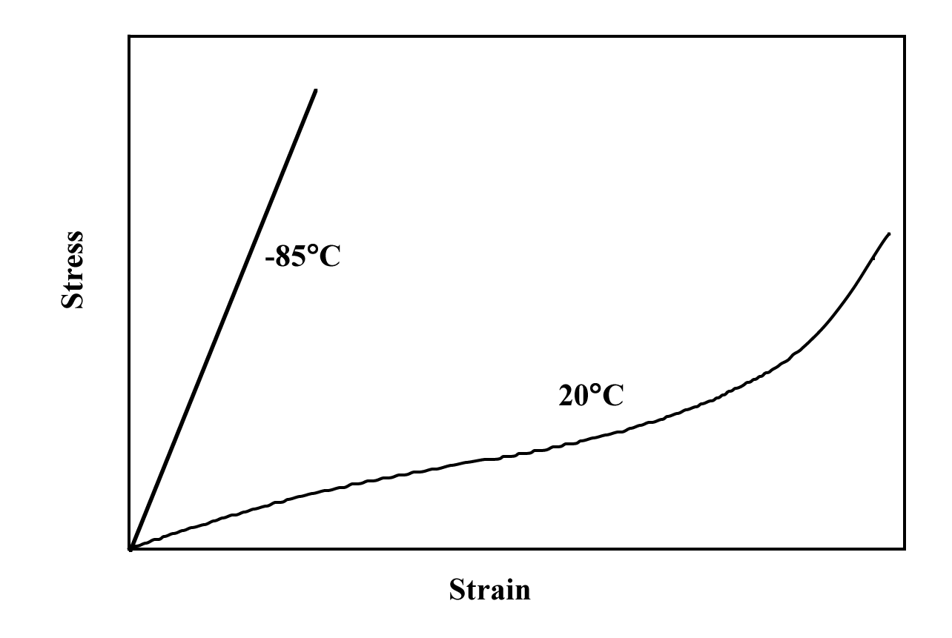

The copolymer tested at 20C will display elastomeric behavior (curve *C* of Figure 7.22) inasmuch as it is a random copolymer that is lightly crosslinked; furthermore, the temperature of testing is above its glass transition temperature. On the other hand, since −85C is below the glass transition temperature of the other poly(styrene-butadiene) copolymer, the stress-strain behavior under these conditions is as curve *A* of Figure 7.22.

Concept Check 8.10

Question: *In terms of molecular structure, explain why phenol-formaldehyde (Bakelite) will not be an elastomer.* *(The molecular structure for phenol-formaldehyde is presented in Table 4.3.)*

Answer: The molecules in elastomers must be two-dimensional chains that are lightly crosslinked and capable of being twisted and kinked in the unstressed state. Phenol-formaldehyde has a rigid three-dimensional structure consisting of trifunctional repeat units, which does not meet these criteria for chain conformation and flexibility.

**Chapter 9**

Failure

Concept Check 9.1

Question: *Cite two situations in which the possibility of failure is part of the design of a component or product.*

Answer: Several situations in which the possibility of failure is part of the design of a component or product are as follows: (1) the pull tab on the top of aluminum beverage cans; (2) aluminum utility/light poles that reside along freeways—a minimum of damage occurs to a vehicle when it collides with the pole; and (3) in some machinery components, a shear pin is used to connect a gear or pulley to a shaft—the pin is designed shear off before damage is done to either the shaft or gear in an overload situation.

Concept Check 9.2

Question: *Make a schematic sketch of a stress-versus-time plot for the situation when the stress ratio R has a value of +1.*

Answer: For a stress ratio (*R*) of +1, then, from Equation 9.18,

max = min

This is to say that the stress remains constant (or does not fluctuate) with time, or the stress-versus-time plot would appear as

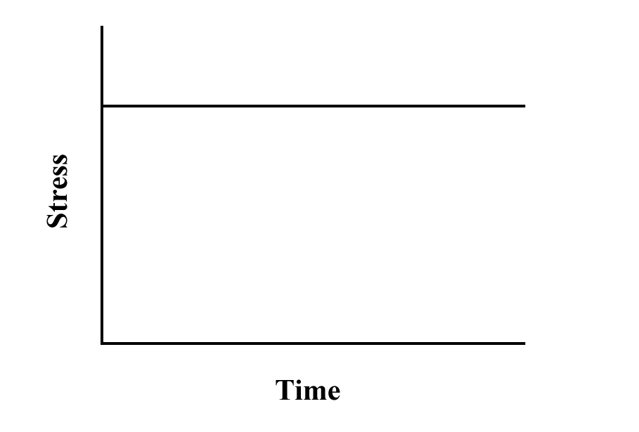

Concept Check 9.3

Question: *Using Equations 9.17 and 9.18, demonstrate that increasing the value of the stress ratio R produces a decrease in stress amplitude* *a*.

Answer: From Equation 9.18



Furthermore, Equation 9.17 is



Substitution of min from the former expression into the latter gives



Therefore, as the magnitude of *R* increases (or becomes more positive) the magnitude of *a* decreases.

Concept Check 9.4

Question: *Surfaces for some steel specimens that have failed by fatigue have a bright crystalline or grainy appearance. Laymen may explain the failure by saying that the metal crystallized while in service. Offer a criticism for this explanation.*

Answer: To crystallize means to become crystalline. Thus, the statement "The metal fractured because it crystallized" is erroneous inasmuch as the metal was crystalline prior to being stressed (virtually all metals are crystalline).

Concept Check 9.5

Question: *Superimpose on the same strain-versus-time plot schematic creep curves for both constant tensile stress and constant tensile load, and explain the differences in behavior.*

Answer: Schematic creep curves at both constant stress and constant load are shown below.

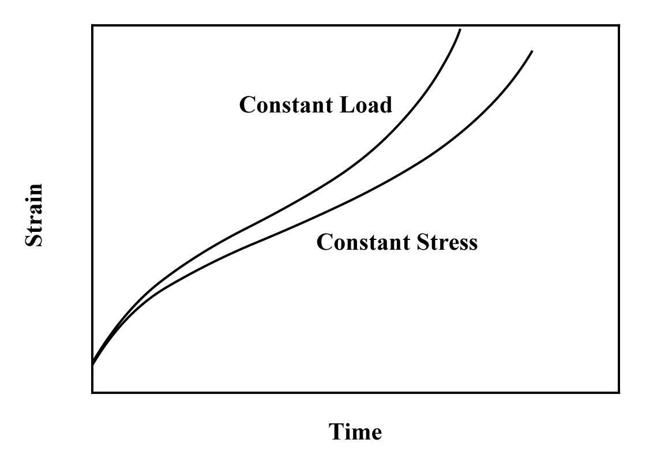

With increasing time, the constant load curve becomes progressively higher than the constant stress curve. Since these tests are tensile ones, the cross-sectional area diminishes as deformation progresses. Thus, in order to maintain a constant stress, the applied load must correspondingly be diminished since stress = load/area.

**Chapter 10**

Phase Diagrams

Concept Check 10.1

Question: *What is the difference between the states of phase equilibrium and metastability?*

Answer: For the condition of phase equilibrium the free energy is a minimum, the system is completely stable meaning that over time the phase characteristics are constant. For metastability, the system is not at equilibrium, and there are very slight (and often imperceptible) changes of the phase characteristics with time.

Concept Check 10.2

Question: *A copper-nickel alloy of composition 70 wt% Ni-30 wt% Cu is slowly heated from a temperature of 1300C.*

*(a)* *At what temperature does the first liquid phase form?*

*(b)* *What is the composition of this liquid phase?*

*(c)* *At what temperature does complete melting of the alloy occur?*

*(d)* *What is the composition of the last solid remaining prior to complete melting?*

Solution: Upon heating a copper-nickel alloy of composition 70 wt% Ni-30 wt% Cu from 1300C and utilizing Figure 10.3*a*:

(a) The first liquid forms at the temperature at which a vertical line at this composition intersects the -( + *L*) phase boundary—i.e., about 1350C;

(b) The composition of this liquid phase corresponds to the intersection with the ( + *L*)-*L* phase boundary, of a tie line constructed across the  + *L* phase region at 1350C—i.e., 59 wt% Ni;

(c) Complete melting of the alloy occurs at the intersection of this same vertical line at 70 wt% Ni with the ( + *L*)-*L* phase boundary—i.e., about 1380C;

(d) The composition of the last solid remaining prior to complete melting corresponds to the intersection with -( +*L*) phase boundary, of the tie line constructed across the  + *L* phase region at 1380C—i.e., about 78 wt% Ni.

Concept Check 10.3

Question: *Is it possible to have a copper-nickel alloy that, at equilibrium, consists of an  phase of composition 37 wt% Ni-63 wt% Cu, and also a liquid phase of composition 20 wt% Ni-80 wt% Cu? If so, what will be the approximate temperature of the alloy? If this is not possible, explain why.*

Answer: It is *not possible* to have a Cu-Ni alloy, which at equilibrium, consists of a liquid phase of composition 20 wt% Ni-80 wt% Cu and an  phase of composition 37 wt% Ni-63 wt% Cu. From Figure 10.3*a*, a single tie line does not exist within the  + *L* region that intersects the phase boundaries at the given compositions. At 20 wt% Ni, the *L*-( + *L*) phase boundary is at about 1200C, whereas at 37 wt% Ni the (*L*+ )- phase boundary is at about 1225C.

Concept Check 10.4

Question: *At 700C (1290F), what is the maximum solubility (a) of Cu in Ag? (b) Of Ag in Cu?*

Answer: (a) From the copper-silver phase diagram, Figure 10.7, the maximum solubility of Cu in Ag at 700C corresponds to the position of the -( + ) phase boundary at this temperature, or to about 6 wt% Cu.

(b) From this same figure, the maximum solubility of Ag in Cu corresponds to the position of the -(+ ) phase boundary at this temperature, or about 5 wt% Ag.

Concept Check 10.5

Question: *Below is a portion of the H2O-NaCl phase diagram:*

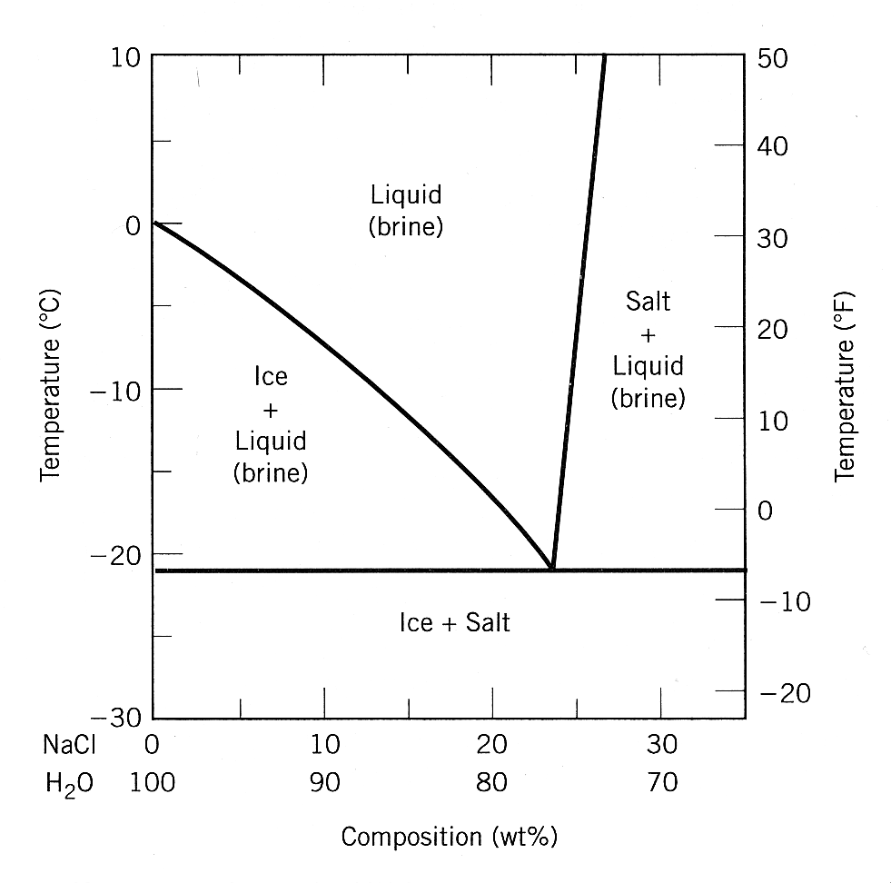

*(a) Using this diagram, briefly explain how spreading salt on ice that is at a temperature below 0C (32F) can cause the ice to melt.*

*(b) At what temperature is salt no longer useful in causing ice to melt?*

Solution: (a) Spreading salt on ice will lower the melting temperature, since the liquidus line decreases from 0C (at 100% H20) to the eutectic temperature at about −21C (23 wt% NaCl). Thus, ice at a temperature below 0C (and above −21C) can be made to form a liquid phase by the addition of salt.

(b) At −21C and below ice is no longer useful in causing ice to melt because this is the lowest temperature at which a liquid phase forms (i.e., it is the eutectic temperature for this system).

Concept Check 10.6

Question: *The following figure is the hafnium-vanadium phase diagram, for which only single-phase regions are labeled. Specify temperature-composition points at which all eutectics, eutectoids, peritectics, and congruent phase transformations occur. Also, for each, write the reaction upon cooling*.

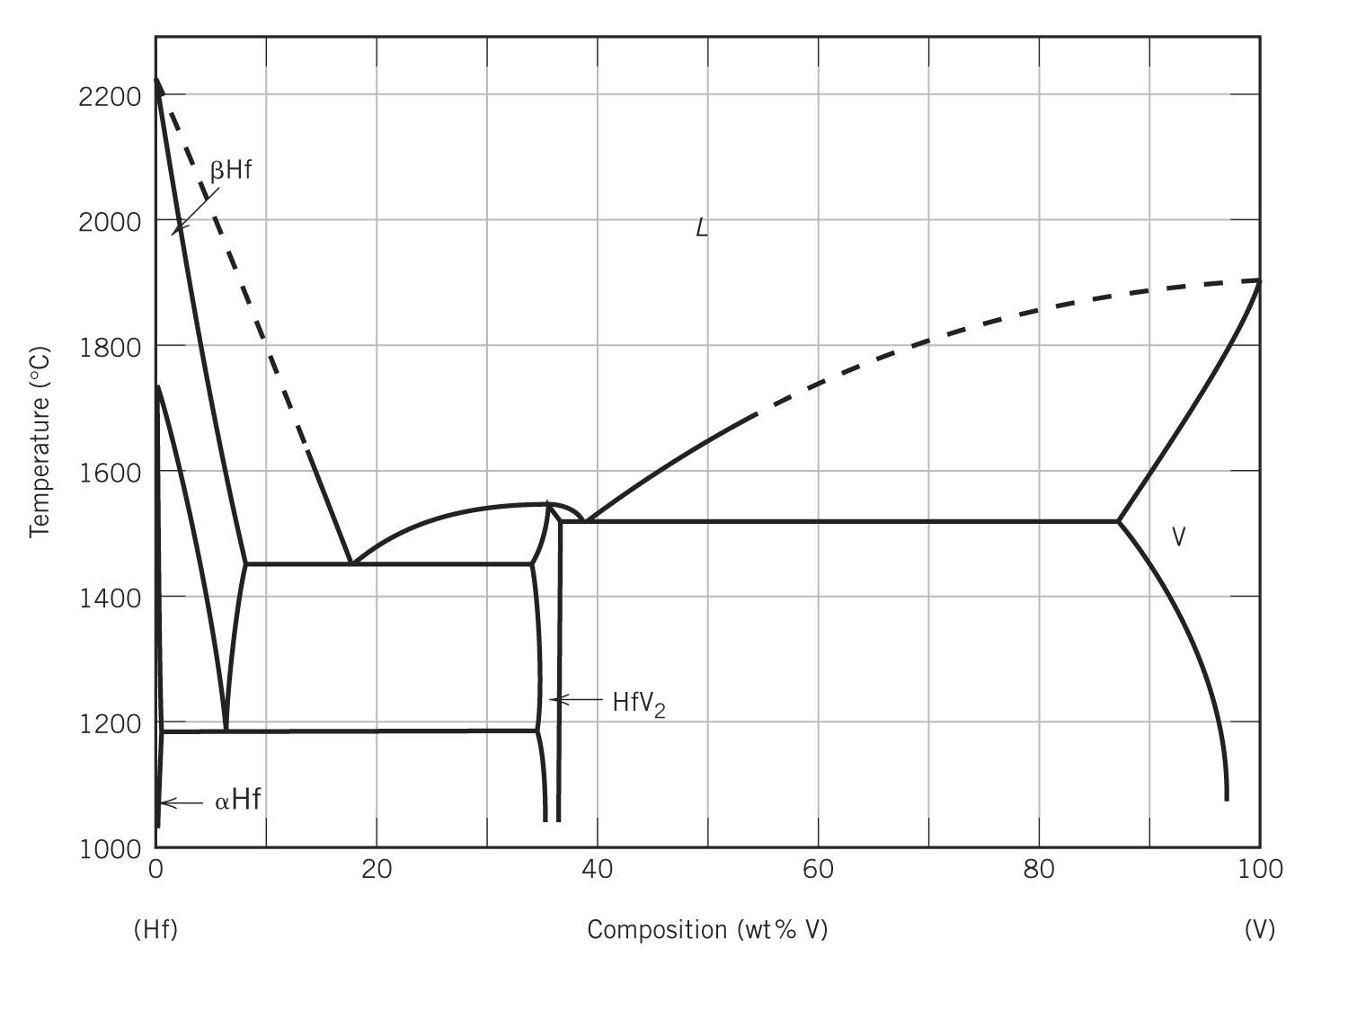

Answer: There are two eutectics on this phase diagram. One exists at 18 wt% V-82 wt% Hf and 1455C. The reaction upon cooling is



The other eutectic exists at 39 wt% V-61 wt% Hf and 1520C. This reaction upon cooling is



There is one eutectoid at 6 wt% V-94 wt% Hf and 1190C. Its reaction upon cooling is



There is one congruent melting point at 36 wt% V-64 wt% Hf and 1550C. The reaction upon cooling is



No peritectics are present.

Concept Check 10.7

Question: *(a)* *For the SiO2-Al2O3 system, what is the maximum temperature that is possible without the formation of a liquid phase?*

*(b)* *At what composition or over what range of compositions will this maximum temperature be achieved?*

Answer: (a) According to Figure 10.26 this maximum temperature is 1890 ± 10C, (b) which is possible for compositions between about 77 wt% Al2O3 and virtually 100 wt% Al2O3.

Concept Check 10.8

Question: *For a ternary system, three components are present; temperature is also a variable. What is the maximum number of phases that may be present for a ternary system, assuming that pressure is held constant?*

Answer: For a ternary system (*C* = 3) at constant pressure (*N* = 1), Gibbs phase rule, Equation 10.16, becomes

*P* + *F* = *C* + *N* = 3 + 1 = 4

Or,

*P* = 4 – *F*

Thus, when *F* = 0, *P* will have its maximum value of 4, which means that the maximum number of phases present for this situation is 4.

Concept Check 10.9

Question: *Briefly explain why a proeutectoid phase (ferrite or cementite) forms along austenite grain boundaries.* *Hint:* *Consult Section 5.8.*

Answer: Associated with grain boundaries is an interfacial energy (i.e., grain boundary energy—Section 5.8). A lower net interfacial energy increase results when a proeutectoid phase forms along existing austenite grain boundaries than when the proeutectoid phase forms within the interior of the grains.

**Chapter 11**

Phase Transformations

Concept Check 11.1

Question: *Which is more stable, the pearlitic or the spheroiditic microstructure? Why?*

Answer: Spheroiditic microstructures are more stable than pearlitic ones. Since pearlite transforms to spheroidite, the latter is more stable

Concept Check 11.2

Question: *Cite two major differences between martensitic and pearlitic transformations.*

Answer: Two major differences are: 1) atomic diffusion is necessary for the pearlitic transformation, whereas the martensitic transformation is diffusionless; and 2) relative to transformation rate, the martensitic transformation is virtually instantaneous, while the pearlitic transformation is time-dependent.

Concept Check 11.3

Question: *Make a copy of the isothermal transformation diagram for an iron-carbon alloy of eutectoid composition (Figure 11.23) and then sketch and label on this diagram a time-temperature path that will produce 100% fine pearlite.*

Answer: Below is shown an isothermal transformation diagram for a eutectoid iron-carbon alloy on which is included a time-temperature path that will produce 100% fine pearlite.

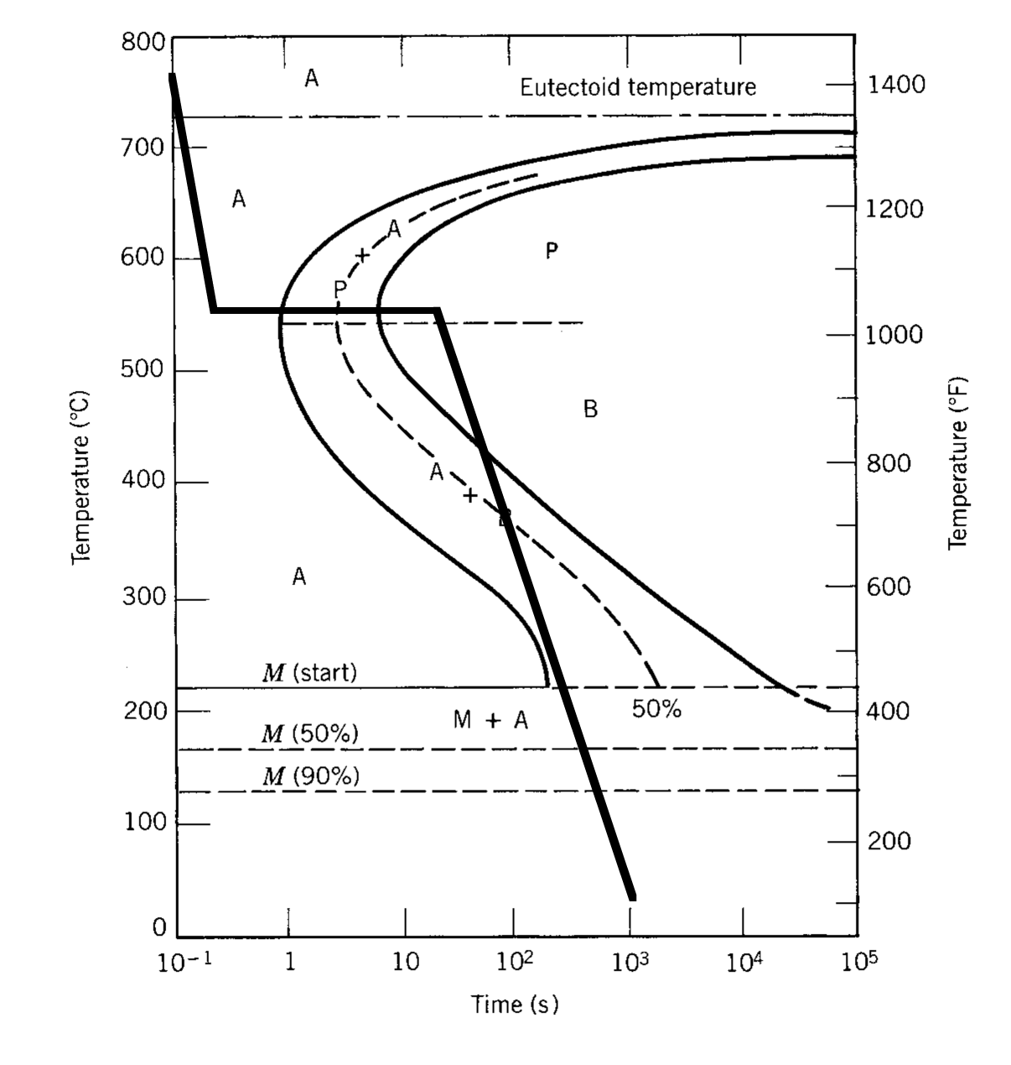

Concept Check 11.4

Question: *Briefly describe the simplest continuous-cooling heat treatment procedure that would be used to convert a 4340 steel from (martensite + bainite) to (ferrite + pearlite).*

Solution: In order to convert from (martensite + bainite) to (ferrite + pearlite) it is necessary to heat above about 720C, allow complete austenitization, then cool to room temperature at a rate equal to or less than 0.006C/s (Figure 11.29).

Concept Check 11.5

Question: *Rank the following iron-carbon alloys and associated microstructures from the highest to the lowest tensile strength:*

*0.25 wt%C with spheroidite*

*0.25 wt%C with coarse pearlite*

*0.60 wt%C with fine pearlite*

*0.60 wt%C with coarse pearlite.*

*Justify this ranking.*

Answer: This ranking called for is as follows:

(1) 0.60 wt%C with fine pearlite

(2) 0.60 wt%C with coarse pearlite

(3) 0.25 wt%C with coarse pearlite

(4) 0.25 wt%C with spheroidite

The 0.25 wt% C, coarse pearlite is stronger than the 0.25 wt% C, spheroidite since coarse pearlite is stronger than spheroidite; the composition of the alloys is the same. The 0.60 wt% C, coarse pearlite is stronger than the 0.25 wt% C, coarse pearlite, since increasing the carbon content increases the strength (while maintained the same coarse pearlite microstructure). Finally, the 0.60 wt% C, fine pearlite is stronger than the 0.60 wt% C, coarse pearlite inasmuch as the strength of fine pearlite is greater than coarse pearlite because of the many more ferrite-cementite phase boundaries in fine pearlite.

Concept Check 11.6

Question: *For a eutectoid steel, describe an isothermal heat treatment that would be required to produce a specimen having a hardness of 93 HRB.*

Answer: From Figure 11.31(a), in order for a 0.76 wt% C alloy to have a Rockwell hardness of 93 HRB, the microstructure must be coarse pearlite. Thus, utilizing the isothermal transformation diagram for this alloy, Figure 11.23, after austenitizing at about 760C, rapidly cool to a temperature at which coarse pearlite forms (i.e., to about 675C), and allow the specimen to isothermally and completely transform to coarse pearlite. At this temperature an isothermal heat treatment for at least 200 s is required. Then cool the specimen to room temperature (cooling rate is not important).

Concept Check 11.7

Question: *A steel alloy is quenched from a temperature within the austenite phase region into water at room temperature so as to form martensite; the alloy is subsequently tempered at an elevated temperature, which is held constant.*

*(a)* *Make a schematic plot showing how room-temperature ductility varies with the logarithm of tempering time at the elevated temperature. (Be sure to label your axes.)*

*(b)* *Superimpose and label on this same plot the room-temperature behavior resulting from tempering at a higher tempering temperature and briefly explain the difference in behavior at these two temperatures.*

Answer: (a) Shown below is the plot that was requested.

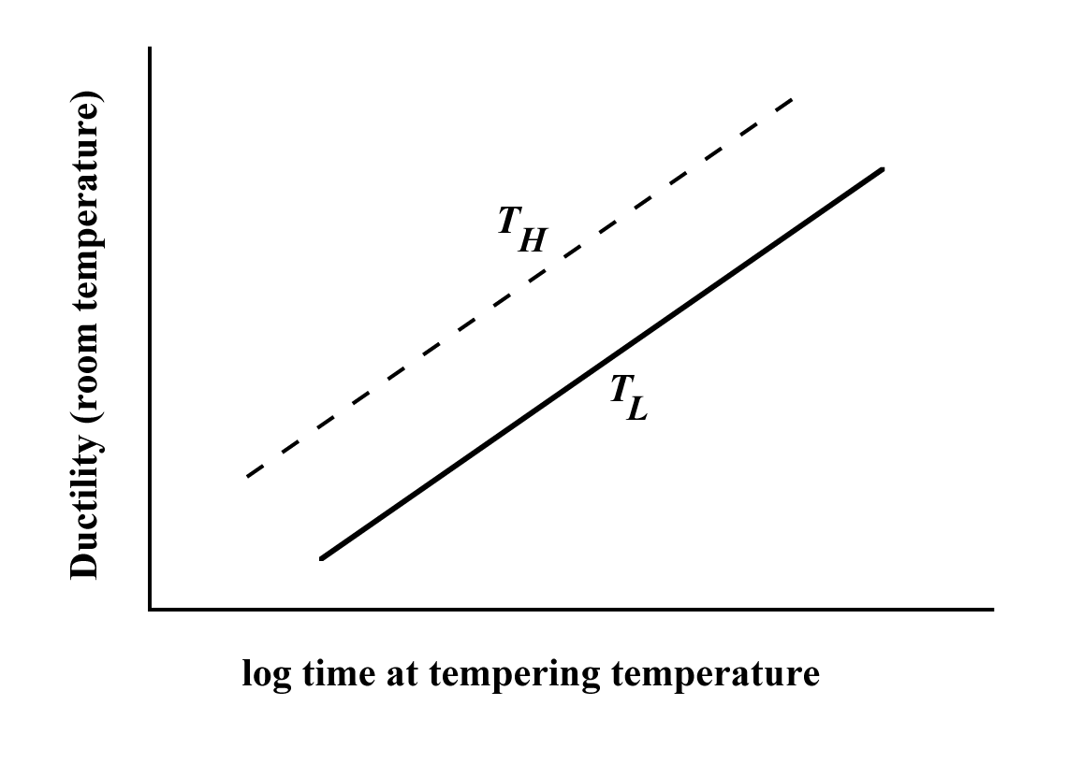

(b) The line for the higher temperature (labeled *TH*) will lie above the one at the lower temperature (labeled *TL*) because the Fe3C particles in tempered martensite will grow faster at the higher temperature; thus, at some given tempering time they will be larger at the higher temperature. The alloy tempered at the higher temperature will be more ductile because there will be fewer -Fe3C phase boundaries (due to the larger Fe3C particles) that may impede dislocation motion.

Concept Check 11.8

Question: *For each of the following two polymers, plot and label a schematic specific volume-versus-temperature curve (include both curves on the same graph):*

*Spherulitic polypropylene, of 25% crystallinity, and having a weight-average molecular weight of 75,000 g/mol*

*Spherulitic polystyrene, of 25% crystallinity, and having a weight-average molecular weight of 100,000 g/mol*

Answer: Shown below are the specific volume-versus-temperature curves for the polypropylene and polystyrene materials.

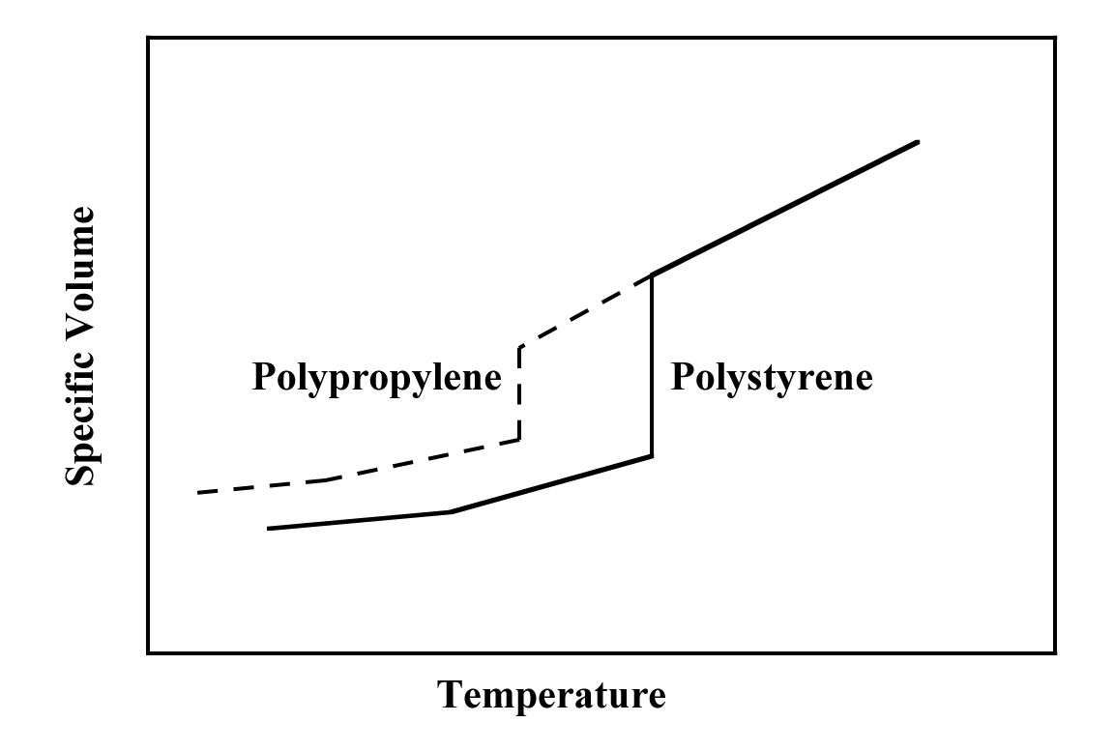

Since both polymers are 25% crystalline, they will exhibit behavior similar to curve *B* in Figure 11.48. However, polystyrene will have higher melting and glass transition temperatures due to the bulkier side group in its repeat unit structure, and since it has a higher weight-average molecular weight.

Concept Check 11.9

Question: *For the following two polymers, (1) state whether or it is possible to determine whether one polymer has a higher melting temperature than the other; (2) if it is possible, note which has the higher melting temperature and then cite reason(s) for your choice; and (3) if it is not possible to decide, then state why not.*

*Isotactic polystyrene that has a density of 1.12 g/cm3 and a weight-average molecular weight of 150,000 g/mol*

*Syndiotactic polystyrene that has a density of 1.10 g/cm3 and a weight-average molecular weight of 125,000 g/mol*

Answer: Yes, it *is possible* to determine which of the two polystyrenes has the higher *Tm*. The isotactic polystyrene will have the higher melting temperature because it has a higher density (i.e., less branching) and also the greater weight-average molecular weight.

**Chapter 12**

Electrical Properties

Concept Check 12.1

Question: *If a metallic material is cooled through its melting temperature at an extremely rapid rate, it will form a noncrystalline solid (i.e., a metallic glass). Will the electrical conductivity of the noncrystalline metal be greater or less than its crystalline counterpart? Why?*

Answer: The electrical conductivity for a metallic glass will be less than for its crystalline counterpart. The glass will have virtually no periodic atomic structure, and, as a result, electrons that are involved in the conduction process will experience frequent and repeated scattering. (There is no electron scattering in a perfect crystal lattice of atoms.)

Concept Check 12.2

Question: *The room-temperature electrical resistivities of pure lead and pure tin are 2.06 x 10-7 and 1.11 x 10-7 -m, respectively.*

*(a) Make a schematic graph of the room-temperature electrical resistivity versus composition for all compositions between pure lead and pure tin.*

*(b) On this same graph schematically plot electrical resistivity versus composition at 150C.*

*(c) Explain the shapes of these two curves, as well as any differences between them.*

*Hint: You may want to consult the lead-tin phase diagram, Figure 10.8*

Answers: (a) and (b) Below is shown the electrical resistivity versus composition for lead-tin alloys at both room temperature and 150C.

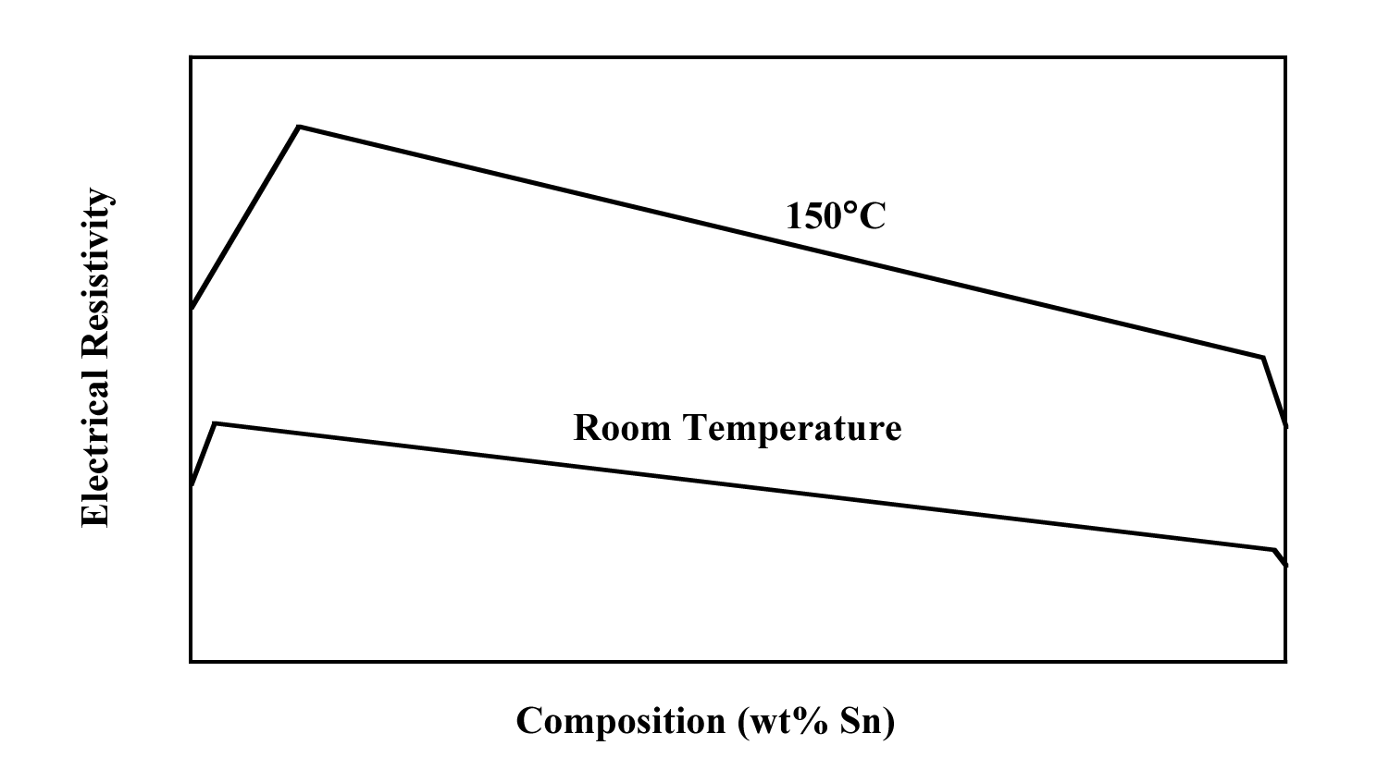

(c) Upon consultation of the Pb-Sn phase diagram (Figure 10.8) we note upon extrapolation of the two solvus lines to at room temperature (e.g., 20C), that the single phase  phase solid solution exists between pure lead and a composition of about 2 wt% of Sn-98 wt% Pb. In addition, the composition range over which the  phase is stable is between approximately 99 wt% Sn-1 wt% Pb and pure tin. Within both of these composition regions the resistivity increases in accordance with Equation 12.11; also, in the above plot, the resistivity of pure Pb is represented (schematically) as being greater than that for pure Sn, per the problem statement.

Furthermore, for compositions between these extremes, both  and  phases coexist, and alloy resistivity will be a function of the resisitivities the individual phases and their volume fractions, as described by Equation 12.12. Also, mass fractions of the  and  phases within the two-phase region of Figure 10.8 change linearly with changing composition (according to the lever rule). There is a reasonable disparity between the densities of Pb and Sn (11.35 g/cm3 versus 7.27 g/cm3). Thus, according to Equation 10.6 phase volume fractions will not exactly equal mass fractions, which means that the resistivity will not exactly vary linearly with composition. In the above plot, the curve in this region has been depicted as being linear for the sake of convenience.

At 150C, the curve has the same general shape, and is shifted to significantly higher resistivities inasmuch as resistivity increases with rising temperature (Equation 12.10 and Figure 12.8). In addition, from Figure 10.8, at 150C the solubility of Sn in Pb increases to approximately 10 wt% Sn—i.e., the  phase field is wider and the increase of resistivity due to the solid solution effect extends over a greater composition range, which is also noted in the above figure. The resistivity-temperature behavior is similar on the tin-rich side, where, at 150C, the  phase field extends to approximately 2 wt% Pb (98 wt% Sn). And, as with the room-temperature case, for compositions within the  +  two-phase region, the plot is approximately linear, extending between resistivity values found at the maximum solubilities of the two phases.

Concept Check 12.3

Question: *Which of ZnS and CdSe will have the larger band gap energy Eg. Cite reason(s) for your choice.*

Answer: Zinc sulfide will have a larger band gap energy than cadmium selenide. Both are II-VI compounds, and Zn and S are both higher vertically in the periodic table (Figure 2.6) than Cd and Se. In moving from bottom to top up the periodic table, *Eg* increases.

Concept Check 12.4

Question: *At relatively high temperatures, both donor- and acceptor-doped semiconducting materials exhibit intrinsic behavior (Section 12.12). On the basis of discussions of Section 12.5 and the previous section, make a schematic plot of Fermi energy versus temperature for an n-type semiconductor up to a temperature at which it becomes intrinsic. Also note on this plot energy positions corresponding to the top of the valence band and the bottom of the conduction band.*

Answer: Below is shown the schematic plot of Fermi temperature versus temperature.

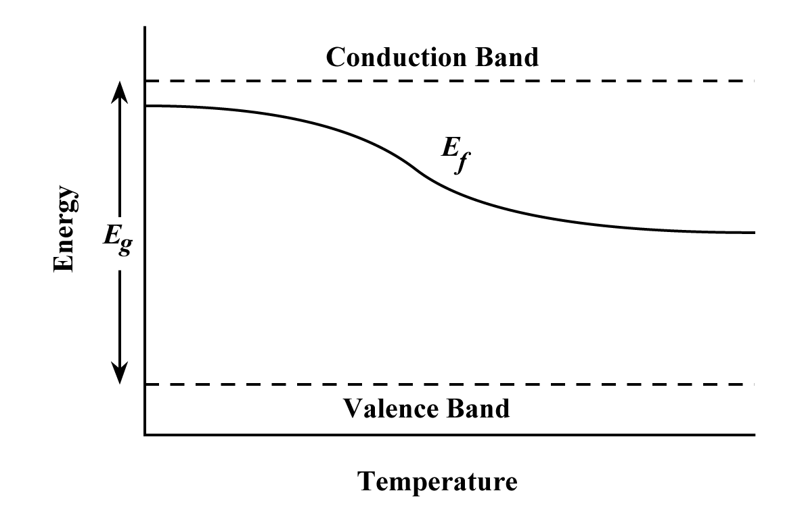

As noted in the previous section, at low temperatures, the material is extrinsic and the Fermi energy is located near the top of the band gap, in the vicinity of the donor level for an *n*-type semiconductor. With increasing temperature, the material eventually becomes intrinsic, and the Fermi energy resides near the center of the band gap (Section 12.5).

Concept Check 12.5

Question: *Will Zn act as a donor or acceptor when added to the compound semiconductor GaAs? Why? (Assume that Zn is a substitutional impurity).*

Answer: Zinc will act as an acceptor in GaAs. Since Zn is from group IIB of the periodic table, it will substitute for Ga; furthermore, a Zn atom has one less valence electron than a Ga atom.

Concept Check 12.6

Question: *On the basis of Figure 12.17, as dopant level is increased would you expect the temperature at which a semiconductor becomes intrinsic to increase, to remain essentially the same, or to decrease? Why?*

Answer: According to Figure 12.17, as dopant level is increased, the position of the horizontal "Extrinsic Region" line moves upward. Thus, the point at which the intrinsic region becomes dominant moves horizontally to higher temperatures.

Concept Check 12.7

Question: *On the basis of the electron-concentration-versus-temperature curve for n-type silicon shown in Figure 12.17 and the dependence of logarithm of electron mobility on temperature (Figure 12.19a), make a schematic plot of logarithm electrical conductivity versus temperature for silicon that has been doped with 1021 m-3 of a donor impurity. Now briefly explain the shape of this curve. Recall that Equation 12.16 expresses the dependence of conductivity on electron concentration and electron mobility*.

Answer: The schematic plot of logarithm electrical conductivity versus temperature is shown below.

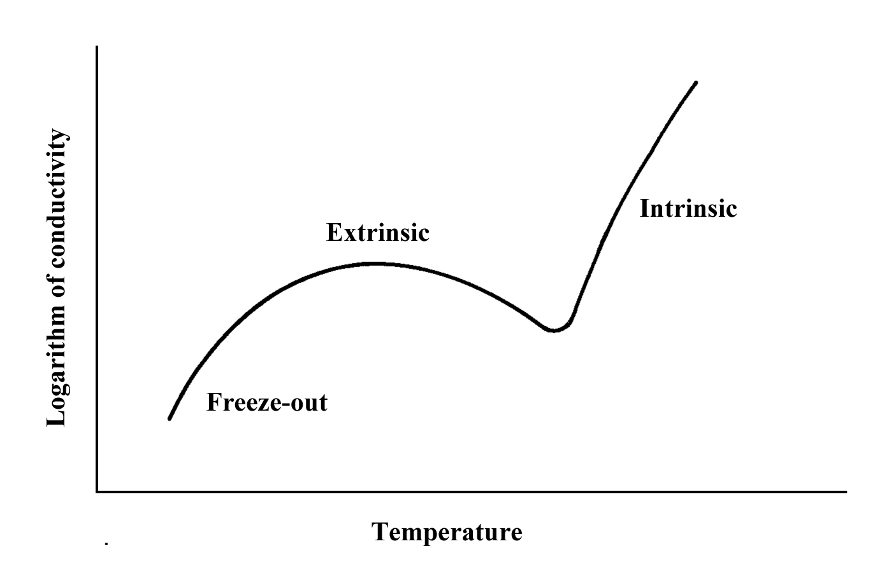

According to Equation 12.16, the electrical conductivity of an *n*-type semiconductor is proportional to the product of electron concentration (*n*) and the electron mobility (*e*)—i.e.,



From Figure 12.19a, there is no curve for *n* = 1021 m-3; however, if one were plotted it would reside between and have the same general shape as the “< 1020 m-3” and “1022 m-3” curves—that is, the logarithm of the electron mobility decreases with increasing temperature. Let us now consider individually the three regions on the log electron concentration versus temperature plot of Figure 12.17. For the “freeze-out” region of the curve (i.e., at low temperatures), the logarithm of the electron concentration increases significantly with increasing temperature. The product of this portion of the curve and the region of the curve in Figure 12.19a over the comparable temperature range results in a net increase in log conductivity with increasing temperature (per the above plot)—the diminishment of log *e* with temperature is more gradual than the increase of log *n*.

Over the “extrinsic region” of Figure 12.17, log *n* remains constant with increasing temperature, whereas log *e* continues to decrease (per Figure 12.19a). The net result of taking the product of these two curves is that conductivity will decrease with increasing temperature. It follows that the log  versus temperature curve will necessarily have to pass through a maximum at some temperature just below the onset of the extrinsic region.

Finally, for the “intrinsic region” of Figure 12.17, log *n* increases dramatically with temperature, and while log *e* continues to decrease (albeit not as dramatically, Figure 12.19a) the net result of taking the product of these two curves is an increase of electrical conductivity with increasing temperature, per the above plot. Furthermore, the log -temperature curve also passes through a minimum at some temperature near the beginning of the intrinsic region of Figure 12.17.

Concept Check 12.8

Question: *Would you expect increasing temperature to influence the operation of p-n junction rectifiers and transistors? Explain.*

Answer: If the temperature of a *p-n* junction rectifier or a junction transistor is raised high enough, the semiconducting materials will become intrinsic and the device will become inoperative. Furthermore, diffusion of dopant species from a *p* to an *n* region and vice versa may occur, which would also lead to performance problems.

Concept Check 12.9

Question: *For solid lead titanate (PbTiO3) what kind(s) of polarization is (are) possible? Why? Note: lead titanate has the same crystal structure as barium titanate (Figure 12.35).*

Answer: *Electronic*, *ionic*, and *orientation* polarizations would be observed in lead titanate. Electronic polarization occurs in all dielectric materials. The lead, titanium, and oxygen would undoubtedly be largely ionic in character. Furthermore, orientation polarization is also possible inasmuch as permanent dipole moments may be induced in the same manner as for BaTiO3 as shown in Figure 12.35.

Concept Check 12.10

Question: *Would you expect the physical dimensions of a piezoelectric material such as BaTiO3 to change when it is subjected to an electric field? Why or why not?*

Answer: Yes, the physical dimensions of a piezoelectric material such as BaTiO3 change when it is subjected to an electric field. As noted in Figure 12.36, a voltage (or electric field) is generated when the dimensions of a piezoelectric material are altered. It would be logical to expect the reverse effect to occur—that is, placing the material within an electric field to cause its physical dimensions to change.

**Chapter 13**

Types and Applications of Materials

Concept Check 13.1

Question: *Briefly explain why ferritic and austenitic stainless steels are not heat treatable. Hint: you may want to consult the first portion of Section 13.3.*

Answer: Ferritic and austenitic stainless steels are not heat treatable since "heat treatable" is taken to mean that martensite may be made to form with relative ease upon quenching austenite from an elevated temperature.

For ferritic stainless steels, austenite does not form upon heating, and, therefore, the austenite-to-martensite transformation is not possible.

For austenitic stainless steels, the austenite phase field extends to such low temperatures that the martensitic transformation does not occur.

Concept Check 13.2

Question: *It is possible to produce cast irons that consist of a martensite matrix in which graphite is embedded in either flake, nodule, or rosette form. Briefly describe the treatment necessary to produce each of these three microstructures.*

Answer: For graphite flakes, gray cast iron is formed (as described in Section 13.2), which is then heated to a temperature at which the ferrite transforms to austenite; the austenite is then rapidly quenched, which transforms to martensite.

For graphite nodules and rosettes, nodular and malleable cast irons are first formed (again as described in Section 13.2), which are then austenitized and rapidly quenched.

Concept Check 13.3

Question: *What is the main difference between brass and bronze?*

Answer: Both brasses and bronzes are copper-based alloys. For brasses, the principal alloying element is zinc, whereas the bronzes are alloyed with other elements such as tin, aluminum, silicon, or nickel.

Concept Check 13.4

Question: *Explain why, under some circumstances, it is not advisable to weld a structure that is fabricated with a 3003 aluminum alloy. Hint: you may want to consult Section 8.13.*

Answer: Strengthening of a 3003 aluminum alloy is accomplished by cold working. Welding a structure of a cold-worked 3003 alloy will cause it to experience recrystallization, and a resultant loss of strength.

Concept Check 13.5

Question: *On the basis of melting temperature, oxidation resistance, yield strength, and degree of brittleness, discuss whether it would be advisable to hot work or to cold work (a) aluminum alloys, and (b) magnesium alloys. Hint: you may want to consult Sections 8.11 and 8.13.*

Answer: Most aluminum alloys may be cold-worked since they are ductile and have relatively low yield strengths.

Magnesium alloys are normally hot-worked inasmuch as they are quite brittle at room temperature. Also, magnesium alloys have relatively low recrystallization temperatures.

Concept Check 13.6

Question: *Briefly explain why glass-ceramics are generally not transparent.*  *Hint: you may want to consult Chapter 19.*

Answer: Glass-ceramics may not be transparent because they are polycrystalline. Light will be scattered at grain boundaries in polycrystalline materials if the index of refraction is anisotropic, and when those grains adjacent to the boundary have different crystallographic orientations. This phenomenon is discussed in Section 19.10. Also, as noted in Section 19.10, glass-ceramics may be transparent if the size of the crystals is smaller than the wavelength of visible light.

Concept Check 13.7

Question: *Upon consideration of the SiO2-Al2O3 phase diagram (Figure 10.26) for the following pair of compositions, which would you judge to be the more desirable refractory? Justify your choice.*

*20 wt% Al2O3-80 wt% SiO2*

*25 wt% Al2O3-75 wt% SiO2*

Answer: The 25 wt% Al2O3-75 wt% SiO2 will be more desirable because the liquidus temperature will be greater for this composition (1740ºC versus 1710ºC); therefore, at any temperature within the mullite + liquid region on the phase diagram, there will be a lower fraction of the liquid phase present than for the 20 wt% Al2O3-80 wt% SiO2 composition, and, thus, the mechanical integrity will be greater.

Concept Check 13.8

Question: *Explain why it is important to grind cement into a fine powder.*

Answer: It is important to grind cement into a fine powder in order to increase the surface area of the particles of cement. The hydration reactions between water and the cement occur at the surface of the cement particles. Therefore, increasing the available surface area allows for more extensive bonding.

Concept Check 13.9

Question: *During the winter months, the temperature in some parts of Alaska may go as low as –55C (–65F). Of the elastomers natural isoprene, styrene-butadiene, acrylonitrile-butadiene, chloroprene, and polysiloxane, which would be suitable for automobile tires under these conditions? Why?*

Answer: From Table 13.14, only natural polyisoprene, poly(styrene-butadiene), and polysiloxane have useful temperature ranges that extend to below −55C. At temperatures below the lower useful temperature range limit, the other elastomers listed in this table become brittle, and, therefore, are not suitable for automobile tires.

Concept Check 13.10

Question: *Silicone polymers may be prepared to exist as liquids at room temperature. Cite differences in molecular structure between them and the silicone elastomers.*  *Hint: You may want to consult Sections 4.5 and 8.19.*

Answer: The liquid silicones will have low molecular weights and very little crosslinking, whereas the molecular weights for the elastomers will be much higher; the elastomers will also have some crosslinking.

**Chapter 14**

Synthesis, Fabrication, and Processing of Materials

Concept Check 14.1

Question: *(a)* *Cite two advantages of powder metallurgy over casting. (b) Cite two disadvantages.*

Answer: (a) Advantages of powder metallurgy over casting are as follows:

1) It is used for alloys having high melting temperatures

2) Better dimensional tolerances result

3) Porosity may be introduced, the degree of which may be controlled (which is desirable in some applications such as self-lubricating bearings)

(b) The disadvantages of powder metallurgy over casting are as follows:

1) Production of the powder is expensive

2) Heat treatment after compaction is necessary

Concept Check 14.2

Question: *What are the principal differences between welding, brazing, and soldering? You may need to consult another reference.*

Answer: For welding, there is melting of the pieces to be joined in the vicinity of the bond; a filler material may or may not be used.

For brazing, a filler material is used which has a melting temperature in excess of about 425C (800F); the filler material is melted, whereas the pieces to be joined are not melted.

For soldering, a filler material is used which has a melting temperature less than about 425C (800F); the filler material is melted, whereas the pieces to be joined are not.

Concept Check 14.3

Question: *Name the three factors that influence the degree to which martensite is formed throughout the cross section of a steel specimen. For each, tell how the extent of martensite formation may be increased.*

Answer: The three factors that influence the degree to which martensite is formed are as follows:

1) Alloying elements; adding alloying elements increases the extent to which martensite forms.

2) Specimen size and shape; the extent of martensite formation increases as the specimen cross-section decreases and as the degree of shape irregularity increases.

3) Quenching medium; the more severe the quench, the more martensite is formed. Water provides a more severe quench than does oil, which is followed by air. Agitating the medium also enhances the severity of quench.

Concept Check 14.4

Question: *How does the thickness of a glassware affect the magnitude of the thermal stresses that may be introduced? Why?*

Answer: The thinner the thickness of a glassware the lower the thermal stresses that are introduced when it is either heated or cooled. The reason for this is that the difference in temperature across the cross-section of the ware, and, therefore, the difference in the degree of expansion or contraction will decrease with a decrease in thickness.

Concept Check 14.5

Question: *Thick ceramic wares are more likely to crack upon drying than thin wares. Why is this so?*

Answer: Thick ceramic wares are more likely to crack upon drying than thin wares because of the differential in shrinkage from the surface to the interior of a cross-section will be greater for a thick ware. The reason for this is that the water being eliminated during drying has a longer distance to travel from the interior to the surface for the thicker ware.

Concept Check 14.6

Question: *Explain why a clay, once it has been fired at an elevated temperature, loses its hydroplasticity.*

Answer: The phenomenon of hydroplasticity results when water molecules form a thin film around the small clay particles. During firing, these individual particles become fused together by the viscous liquid that fills in the pore volume between the particles—the pore volume that was occupied by water in the hydroplastic state. This viscous liquid forms a glass matrix on subsequent cooling.

Concept Check 14.7

Question: *State whether the molecular weight of a polymer that is synthesized by addition polymerization is relatively high, medium, or relatively low for the following situations:*

*(a)* *Rapid initiation, slow propagation, and rapid termination*

*(b)* *Slow initiation, rapid propagation, and slow termination*

*(c)* *Rapid initiation, rapid propagation, and slow termination*

*(d)* *Slow initiation, slow propagation, and rapid termination*

Answer:

(a) For rapid initiation, slow propagation, and rapid termination the molecular weight will be relatively low.

(b) For slow initiation, rapid propagation, and slow termination the molecular weight will be relatively high.

(c) For rapid initiation, rapid propagation, and slow termination a medium molecular weight will be achieved.

(d) For slow initiation, slow propagation, and rapid termination the molecular weight will be low or medium.

Concept Check 14.8

Question: *Nylon 6,6 may be formed by means of a condensation polymerization reaction in which hexamethylene diamine [NH2—(CH2)6—NH2] and adipic acid react with one another with the formation of water as a by-product. Write out this reaction in the manner of Equation 14.5.*  *Note: the structure for adipic acid is*

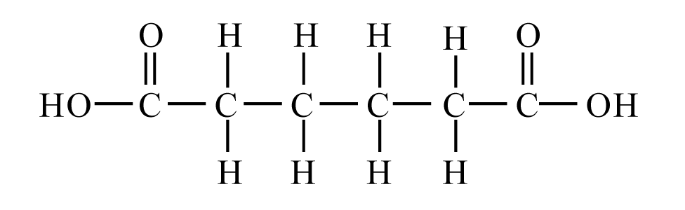

Answer: The following represents the reaction between hexamethylene diamine and adipic acid to produce nylon 6,6 with water as a byproduct:

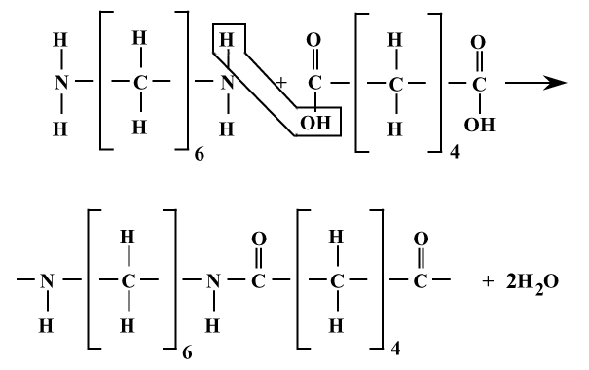

Concept Check 14.9

Question:

*(a)* *Why must the vapor pressure of a plasticizer be relatively low?*

*(b)* *How will the crystallinity of a polymer be affected by the addition of a plasticizer? Why?*

*(c)* *How does the addition of a plasticizer influence the tensile strength of a polymer? Why?*

Answers:

(a) If the vapor pressure of a plasticizer is not relatively low, the plasticizer may vaporize, which will result in an embrittlement of the polymer.

(b) The crystallinity of a polymer to which has been added a plasticizer will be diminished, inasmuch as the plasticizer molecules fit in between the polymer molecules, which will cause more misalignment of the latter.

(c) The tensile strength of a polymer will be diminished when a plasticizer is added. As the plasticizer molecules force the polymer chain molecules apart, the magnitudes of the secondary interchain bonds are lessened, which weakens the material since strength is a function of the magnitude of these bonds.

Concept Check 14.10

Question: *For a rubber component that is to be vulcanized in its final form, should vulcanization be carried out before or after the forming operation? Why? Hint: you may want to consult Section 8.19.*

Answer: Vulcanization of a rubber component should be carried out prior to the forming operation since, once it has been vulcanized, plastic deformation (and thus forming) is not possible since chain crosslinks have been introduced.

**Chapter 15**

Composites

Concept Check 15.1

Question: *Cite the general difference in strengthening mechanism between large-particle and dispersion-strengthened particle-reinforced composites.*

Answer: The major difference in strengthening mechanism between large-particle and dispersion-strengthened particle-reinforced composites is that for large-particle the particle-matrix interactions are not treated on the molecular level, whereas, for dispersion-strengthening these interactions are treated on the molecular level.

Concept Check 15.2

Question: *The following table lists four hypothetical aligned fiber-reinforced composites (labeled A through D), along with their characteristics. On the basis of these data, rank the four composites from highest to lowest strength in the longitudinal direction, and then justify your ranking.*

Fiber Ave. Fiber Critical

Composite Fiber Vol. Fraction Strength Length Length

Type Fibers (MPa) (mm) (mm)

A glass 0.20 3.5 × 103 8 0.70

B glass 0.35 3.5 × 103 12 0.75

C carbon 0.40 5.5 × 103 8 0.40

D carbon 0.30 5.5 × 103 8 0.50

Answer: The ranking from highest to lowest strength in the longitudinal direction is as follows: C, D, B, and A. Composite C is the strongest inasmuch as the carbon fibers are continuous and are stronger than glass, and it has the highest fiber volume fraction. Composite D is of lower strength than C because it has a lower *Vf* ; otherwise the carbon fibers are also continuous. Material B is next because the glass fibers are weaker than carbon; these fibers are also continuous. Composite A is the weakest since it is composed of the weaker glass fibers, the fibers are discontinuous, and *Vf* is the lowest of all four materials.

Concept Check 15.3

Question: *Cite one desirable characteristic and one less desirable characteristic for each of (1) discontinuous and oriented fiber-reinforced composites and (2) discontinuous and randomly oriented fiber-reinforced composites.*

Answer: For discontinuous-oriented fiber-reinforced composites one desirable characteristic is that the composite is relatively strong and stiff in one direction; a less desirable characteristic is that the mechanical properties are anisotropic.

For discontinuous and random fiber-reinforced, one desirable characteristic is that the properties are isotropic; a less desirable characteristic is there is no single high-strength direction.

**Chapter 16**

Corrosion and Degradation of Materials

Concept Check 16.1

Question: *Would you expect iron to corrode in water of high purity? Why or why not?*

Answer: Iron would not corrode in water of high purity because all of the reduction reactions, Equations 16.3 through 16.7, depend on the presence of some impurity substance such as H+ or M*n*+ ions or dissolved oxygen.

Concept Check 16.2

Question: *Modify Equation 16.19 for the case in which metals M1 and M2 are alloys.*

Answer: For this case, it is necessary to take into account the compositions of metals M1 and M2. If [M1] and [M2] represent concentrations of metals M1 and M2 in their respective alloys, the equation becomes



Concept Check 16.3

Question: *Briefly explain why concentration polarization is not normally rate controlling for oxidation reactions.*

Answer: Concentration polarization is not normally rate controlling for oxidation reactions because there will always be an unlimited supply of metal atoms at the corroding electrode interface.

Concept Check 16.4

Question:  *(a)*  *From the galvanic series (Table 16.2), cite three metals or alloys that may be used to galvanically protect nickel in the active state.*

*(b)* *Sometimes galvanic corrosion is prevented by making an electrical contact between both metals in the couple and a third metal that is anodic to these other two. Using the galvanic series, name one metal that could be used to protect a copper-aluminum galvanic couple.*

Solution: (a) The following metals and alloys may be used to galvanically protect nickel in the active state (i.e., lie below Ni in the galvanic series): tin, lead, 316 and 304 stainless steels, cast iron, iron, steel, aluminum alloys, cadmium, commercially pure aluminum, zinc, magnesium, and magnesium alloys.

(b) Zinc, magnesium, and magnesium alloys may be used to protect a copper-aluminum galvanic couple.

Concept Check 16.5

Question: *Cite two examples of the beneficial use of galvanic corrosion*. *Hint: One example is cited later in this chapter.*

Answer: Two beneficial uses of galvanic corrosion are corrosion prevention by means of cathodic protection and the dry-cell battery.

Concept Check 16.6

Question: *Is Equation 16.23 equally valid for uniform corrosion and pitting? Why or why not?*

Answer: Equation 16.23 is *not* equally valid for uniform corrosion and pitting. The reason for this is that, with pitting, the corrosion attack is very localized, and a pit may penetrate the entire thickness of a piece (leading to failure) with very little material loss and a very small corrosion penetration rate. With uniform corrosion, the corrosion penetration rate accurately represents the extent of corrosion damage.

Concept Check 16.7

Question: *Tin cans are made of a steel, the inside of which is coated with a thin layer of tin. The tin protects the steel from corrosion by food products in the same manner as zinc protects steel from atmospheric corrosion. Briefly explain how this cathodic protection of tin cans is possible, given that tin is electrochemically less active than steel in the galvanic series (Table 16.2)*.

Answer: Tin offers galvanic protection to the steel in tin cans even though it (tin) is electrochemically less active than steel from the galvanic series. The reason for this is that the galvanic series represents the reactivities of metals and alloys in seawater; however, for the food solutions that are contained within the cans, tin is the more active metal.

Concept Check 16.8

Question: *From a molecular perspective, explain why increasing crosslinking and crystallinity of a polymeric material will enhance its resistance to swelling and dissolution. Would you expect crosslinking or crystallinity to have the greater influence? Justify your choice. Hint: you may want to consult Sections 4.7 and 4.11.*

Answer: During swelling and dissolution of polymeric materials, the solute molecules diffuse to and occupy positions among the polymer macromolecules, and thereby force the latter apart. Increasing both the degrees of crosslinking and crystallinity will enhance a polymer's resistance to these types of degradation since there will be a greater degree of intermolecular bonding between adjacent chains; this restricts the number of solute molecules that can fit into these locations.

Crosslinking will be more effective. For linear polymers that are highly crystalline, the intermolecular bonds are secondary ones (van der Waals and/or hydrogen), and relatively weak in comparison to the strong covalent bonds associated with the crosslinks.

Concept Check 16.9

Question: *List three differences between the corrosion of metals and each of the following:*

*(a)* *The corrosion of ceramics*

*(b)* *The degradation of polymers*

Answer:

(a) Three differences between the corrosion of metals and the corrosion of ceramics are:

1) Ceramic materials are more corrosion resistant than metals in most environments.

2) Corrosion of ceramic materials is normally just a chemical dissolution process, whereas for metals it is usually electrochemical.

3) Ceramics are more corrosion resistant at elevated temperatures.

(b) Three differences between the corrosion of metals and the degradation of polymers are:

1) Degradation of polymers is ordinarily physiochemical, whereas for metals, corrosion is electrochemical.

2) Degradation mechanisms for polymers are more complex than the corrosion mechanisms for metals.

3) More types of degradation are possible for polymers—e.g., dissolution, swelling, and bond rupture (by means of radiation, heat, and chemical reactions).

**Chapter 17**

Thermal Properties

Concept Check 17.1

Question: *(a)* *Explain why a brass lid ring on a glass canning jar will loosen when heated.*

*(b)* *Suppose the ring is made of tungsten instead of brass. What will be the effect of heating the lid and jar? Why?*

Answer: (a) A brass lid on a glass canning jar will loosen when heated because brass has the greater coefficient of thermal expansion [20 × 10-6 (C)-1 versus approximately 9 × 10-6 (C)-1 for glass, Table 17.1].

(b) If the ring is made of tungsten instead of brass, the ring will tighten upon heating inasmuch as the glass will expand more than tungsten. The values of *l* for glass and tungsten are 9 × 10-6 (C)-1 and 4.5 × 10-6 (C)-1, respectively.

Concept Check 17.2

Question: *The thermal conductivity of a plain carbon steel is greater than for a stainless steel. Why is this so?*  *Hint: you may want to consult Section 13.2.*

Answer: The thermal conductivity of a plain carbon steel is greater than for a stainless steel because the stainless steel has much higher concentrations of alloying elements. Atoms of these alloying elements serve as scattering centers for the free electrons that are involved in the thermal transport process.

Concept Check 17.3

Question: *The thermal conductivity of a single-crystal ceramic specimen is slightly greater than a polycrystalline one of the same material. Why is this so?*

Answer: The thermal conductivity of a single crystal is greater than a polycrystalline specimen of the same material because both phonons and free electrons are scattered at grain boundaries, thus decreasing the efficiency of thermal transport.

Concept Check 17.4

Question: *Which of a linear polyethylene ( = 450,000 g/mol) and a lightly branched polyethylene ( = 650,000 g/mol) has the higher thermal conductivity? Why? Hint: you may want to consult Section 4.11.*

Answer: The linear polyethylene will have a larger conductivity than the lightly branched polyethylene because the former will have a higher degree of crystallinity by virtue of its linear molecular structure. Since heat transfer is accomplished by molecular chain vibrations, and the coordination of these vibrations increases with percent crystallinity, the higher the crystallinity, the greater the thermal conductivity.

Concept Check 17.5

Question: *Explain why, on a cold day, the metal door handle of an automobile feels colder to the touch than a plastic steering wheel, even though both are at the same temperature.*

Answer: On a cold day, the metal door handle feels colder than the plastic steering wheel because metal has the higher thermal conductivity, and, therefore, conducts heat away from one's skin more rapidly.

**Chapter 18**

Magnetic Properties

Concept Check 18.1

Question: *Cite the major similarities and differences between ferromagnetic and ferrimagnetic materials.*

Answer:

The similarities between ferromagnetic and ferrimagnetic materials are as follows:

(1) There is a coupling interaction between magnetic moments of adjacent atoms/cations for both material types.

(2) Both ferromagnets and ferrimagnets form domains.

(3) Hysteresis *B-H* behavior is displayed for both, and, thus, permanent magnetizations are possible.

The differences between ferromagnetic and ferrimagnetic materials are as follows:

(1) Magnetic moment coupling is parallel for ferromagnetic materials, and antiparallel for ferrimagnetic.

(2) Ferromagnetics, being metallic materials, are relatively good electrical conductors; inasmuch as ferrimagnetic materials are ceramics, they are electrically insulative.

(3) Saturation magnetizations are higher for ferromagnetic materials.

Concept Check 18.2

Question: *What is the difference between the spinel and inverse spinel crystal structures? Hint: You may want to consult Section 3.16.*

Answer: Both spinel and inverse spinel crystal structures consist of FCC close-packed stackings of anions (O2- ions). Two types of sites, tetrahedral and octahedral, exist among the anions, which may be occupied by the cations. The divalent cations (e.g., Fe2+) occupy tetrahedral sites for the spinel structure and octahedral sites for inverse spinel. On the other hand, trivalent cations (e.g., Fe3+) ions reside on octahedral sites for the spinel structure, whereas, for the inverse spinel, half are positioned on tetrahedral sites, the other half on octahedral.

Concept Check 18.3

Question: *Explain why repeatedly dropping a permanent magnet on the floor will cause it to become demagnetized.*

Answer: Repeatedly dropping a permanent magnet on the floor will cause it to become demagnetized because the jarring causes large numbers of magnetic dipoles to become misaligned by dipole rotation.

Concept Check 18.4

Question: *Schematically sketch on a single plot the B-versus-H behavior for a ferromagnetic material*

*(a)* *at 0 K,*

*(b)* *at a temperature just below its Curie temperature, and*

*(c)* *at a temperature just above its Curie temperature. Briefly explain why these curves have different shapes.*

Answer: These *B*-versus-*H* behaviors are sketched schematically below.

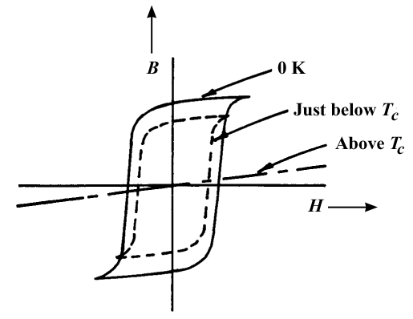

At 0 K, the saturation magnetization will be a maximum, and the hysteresis loop will have the largest area. At a higher temperature (yet below the Curie temperature) the saturation magnetization will decrease and the size of the hysteresis loop will diminish. Finally, above the Curie temperature, ferromagnetic behavior ceases, and the material becomes paramagnetic, with linear *B*-versus-*H* behavior; the slope of this line segment is very gentle.

Concept Check 18.5

Question: *Schematically sketch the hysteresis behavior for a ferromagnet that is gradually demagnetized by cycling in an H field that alternates direction and decreases in magnitude.*

Answer: A schematic sketch showing the hysteresis behavior for a ferromagnet that is gradually demagnetized by cycling an *H* field that alternates direction and decreases in magnitude is shown below.

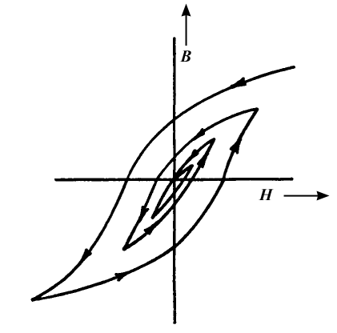

Concept Check 18.6

Question: *It is possible, by various means (e.g., alteration of microstructure and impurity additions), to control the ease with which domain walls move as the magnetic field is changed for ferromagnetic and ferrimagnetic materials. Sketch a schematic B-versus-H hysteresis loop for a ferromagnetic material, and superimpose on this plot the loop alterations that would occur if domain boundary movement were hindered.*

Answer: Hindering domain boundary movement will enhance the coercivity of the magnetic material, without producing a significant alteration of the saturation flux density. Thus, schematic *B-H* behaviors with and without domain boundary obstruction are shown below.

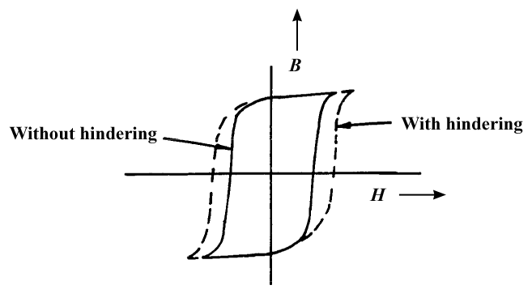

**Chapter 19**

Optical Properties

Concept Check 19.1

Question: *Briefly discuss the similarities and differences between photons and phonons. Hint: you may want to consult Section 17.2.*

Answer:

Similarities between photons and phonons are:

1) Both may be described as being wavelike in nature.

2) The energy for both is quantized.

Differences between photons and phonons are:

1) Phonons are elastic waves that exist within solid materials. Photons are electromagnetic energy packets that may exist in solid materials, as well as in other media.

2) There is a considerable disparity between the velocities of photons and phonons. The velocity of a photon is the same as the velocity of light in the particular medium; for a phonon, its velocity is that of sound.

Concept Check 19.2

Question: *Electromagnetic radiation may be treated from the classical or the quantum-mechanical perspectives. Briefly compare these two viewpoints.*

Answer: From the classical perspective, electromagnetic radiation is wave-like in character, and the possible energies of the radiation are continuous. From the quantum-mechanical perspective, electromagnetic radiation is dual-like in character (being both wavelike and particle-like), and not all energies are possible (i.e., energy is quantized).

Concept Check 19.3

Question: *Why are metals transparent to high-frequency x-ray and -ray radiation?*

Answer: Metals are transparent to high-frequency x-ray and -ray radiation since the energies of these types of radiation are greater than for visible light; electron excitations corresponding to these energies (with energy absorption) are not possible because energies for such transitions would be to within an energy band gap beyond the highest partially-filled energy band.

Concept Check 19.4

Question: *Which of the following oxide materials when added to fused silica (SiO2) will increase its index of refraction: Al2O3, TiO2, NiO, MgO? Why? You may find Table 3.4 helpful.*

Answer: In ionic materials, the larger the size of the component ions the greater the degree of electronic polarization. Upon consultation of Table 3.4 we find that the Al3+, Ti4+, Ni2+, and Mg2+ ions are all greater in size than the Si4+ ion (0.053, 0.061, 0.069, and 0.0.072 nm, respectively, versus 0.040 nm), and, therefore, all of these ions will increase the index of refraction when added to SiO2.

Concept Check 19.5

Question: *Are the elemental semiconductors silicon and germanium transparent to visible light? Why or why not? Hint: you may want to consult Table 12.3.*

Answer: We want to decide whether Si and Ge are transparent to visible light on the basis of their band gap energies. Table 12.3 cites 1.11 and 0.67 eV, respectively, as the *Eg*'s for these two semiconductors. According to Equation 19.16b, semiconductors having band gap energies less than about 1.8 eV are opaque to visible light. Thus, both Si and Ge fall into this category, and all visible light is absorbed by valence-band-to-conduction-band-electron transitions across their reasonably narrow band gaps.

Concept Check 19.6

Question: *Compare those factors that determine the characteristic colors of metals and transparent nonmetals.*

Answer: The characteristic color of a metal is determined by the distribution of wavelengths of the nonabsorbed light radiation that is reflected. The characteristic color of a transparent nonmetal is determined by the distribution of wavelengths of the nonabsorbed light radiation that is transmitted through the material.

Concept Check 19.7

Question: *Is the semiconductor zinc selenide (ZnSe), which has a band gap of 2.58 eV, photoconductive when exposed to visible light radiation? Why or why not?*

Answer: Zinc selenide, having a band gap of 2.58 eV, is photoconductive. In order to be photoconductive, electrons must be excited from the valence band into the conduction band by the absorption of light radiation. According to Equation 19.16a, the maximum band gap energy for which there may be absorption of visible light is 3.1 eV; since the band gap energy for ZnSe is less than this value, photoinduced valence-band-to-conduction-band electron transitions will occur.